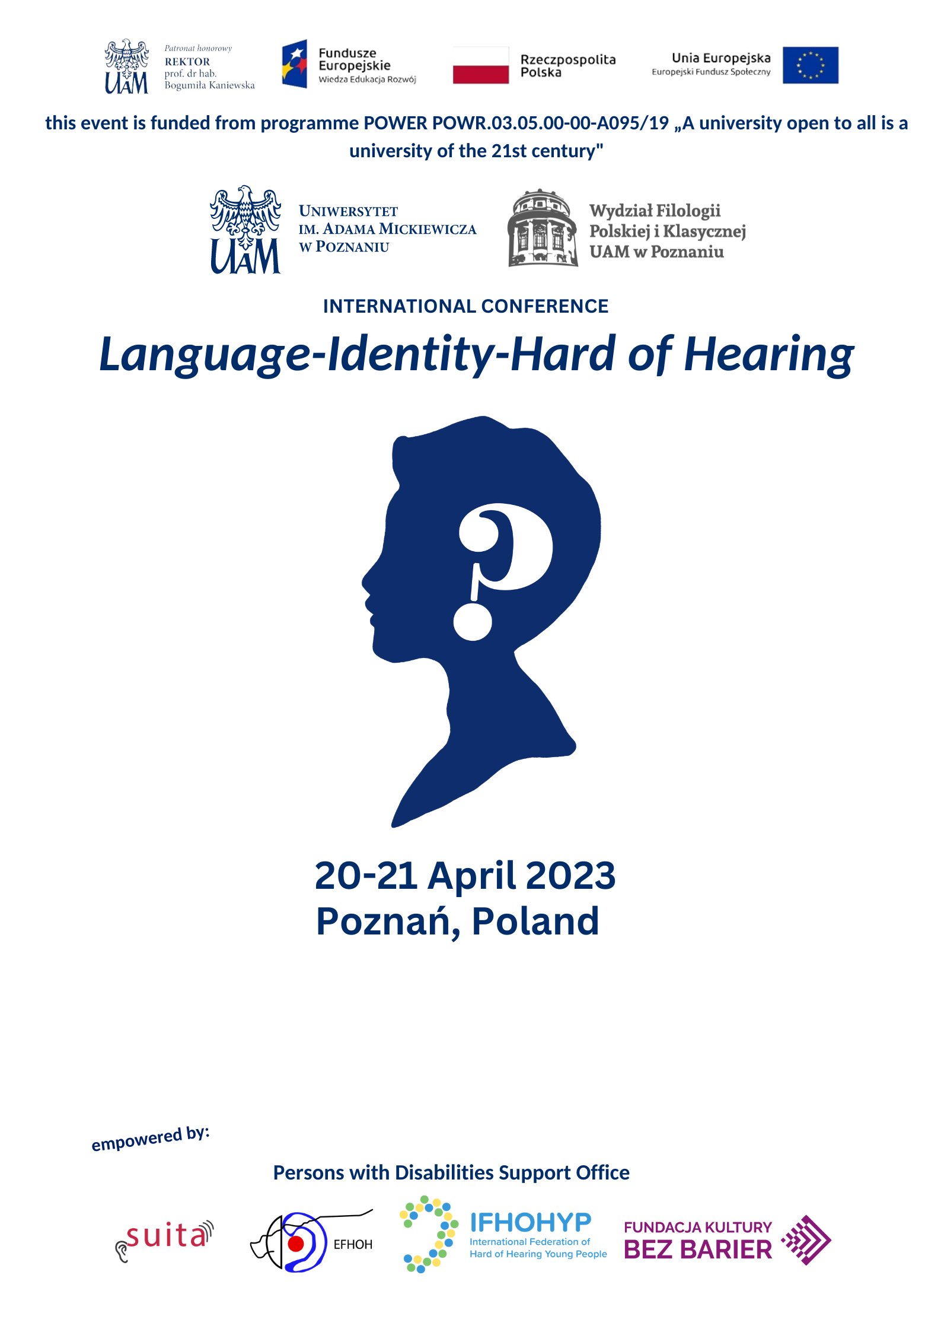

PROGRAMME OF THE CONFERENCE

20 th of April (Thursday)
Place of the event: the aula of the Department of Political Science and Journalism, Uniwersytetu Poznańskiego 5 Street

9.00 | Conference opening – The Dean of the Department of Polish and Classical Philology, Tomasz Mizerkiewicz
9.15 | Welcoming participants – The Head of the Institute of Polish Philology, Elżbieta Winiecka
9.25 | Welcoming participants – The Head of the Support Office of the Students with Disabilities, Anna Rutz
9.35 | Introduction to the organizational aspects of the conference – Karolina Ruta-Korytowska

THE PRESENTATIONS’ ORDER:

9.45-10.10 | Ewa Domagała-Zyśk (Lublin, Poland), Multilinguals. On the perspectives of language learning for the hard of hearing in hybrid education
10.10-10.35 | Katarzyna Karpińska-Szaj (Poznań, Poland), Hard of hearing student as a foreign language learner. Individualization of language education in glottodidactic research of hybrid education
10.35-11.00 | Jitka Sedláčková, (Brno, Czech Republic), The foreign language instruction of hard of hearing students in inclusive settings from the perspective of their teachers
11.00-11.25 | Anna Nabiałek, Marta Rudnicka (Poznań, Poland), How to teach Deaf and hoh students a foreign language: language learning and identity - is there a link?
11.25-11.50 | Karolina Ruta-Korytowska, Level of reading and writing skills among d/Deaf and hard of hearing students in a comparative perspective
11.50-12.15 | Coffee break
12.15-12.40 | Marta Chomicz (Warsaw, Poland), Teaching writing skills in English as a foreign language to D/HH students
12.40-13.05 | Beata Gulati (Siedlce, Poland), Visual materials in teaching HoHs foreign language
13.05-13.30 | Paulina Lewandowska (Lublin, Poland), HoH's communication barriers (and possible solutions?) when using a foreign language (English) abroad
13.30-13.55 | Claire Sabler Landesman (European Federation of Hard of Hearing, Austria), The importance of language learning for children from the perspective of a HoH teacher/counsellor of children diagnosed with reading and writing issues
13.55-14.20 | Lenka Tóthová (Brno, Czech Republic), Is the world open to everyone? HoH students and mobilities
14.20-14.45 | Discussion panel
14.45-15.45 | Lunch break
16.00-17.30 | Workshop on techniques of learning foreign languages for hard of hearing students (coordinated by: Lenka Tóthová and Jitka Sedláčková from Masaryk University in Brno)
18.00-19.00 | Dinner

21st of April (Friday)
Place of the event: the aula of the Department of Chemistry, Uniwersytetu Poznańskiego 8 Street (300 m from the Aula WNPiD)

9.00-9.25 | Stéphanie Gobet (Poitiers, France), How social activities and research for access to HoH education are combined?
9.25-9.50 | Lidia Best (London, United Kingdom), How can we advocate the rights to equitable education for Hard of Hearing People?
9.50-10.15 | Paulina Zagrobelna (Warsaw, Poland), Assistive devices and its role for Hard of Hearing
10.15-10.40 | Eilidh Rose MacEoghainn (Scotland, United Kingdom), The capabilities of deaf people in international development projects in global south
10.40-11.00 | Coffee break
11.00-11.25 | Bowen Tang (Vancouver, Canada), How do organizations influence the quality of life of students? Power of Community and Peer Support in Fostering Access and Inclusion
11.25-11.50 | Jonathan Elebjörk Wahlström (Stockholm, Sweden), How do we do policy when we talk about hard of hearing? The problem of identity
11.50-12.15 | Maria Skoczyńska (Poznań, Poland), In betweenness – HoH social/psychological/educational representation
12.05-12.20 | Dominika Kopańska (Lublin, Poland), Autoethnographic approach in research on the identity of a hearing impaired person living on the border of two worlds: sounds and sign language
12:20-12:40 | Claudia Hernandez (Barcelona, Spain), Internal and external factors that promote emotional well-being in young people with sudden deafness
12.40-13.00 | Discussion panel and the closure of the conference
13.00-14.00 | Lunch

